**RAIF FAWWAZDZAKY**

**1202200054**

**SI4407**

Index.php

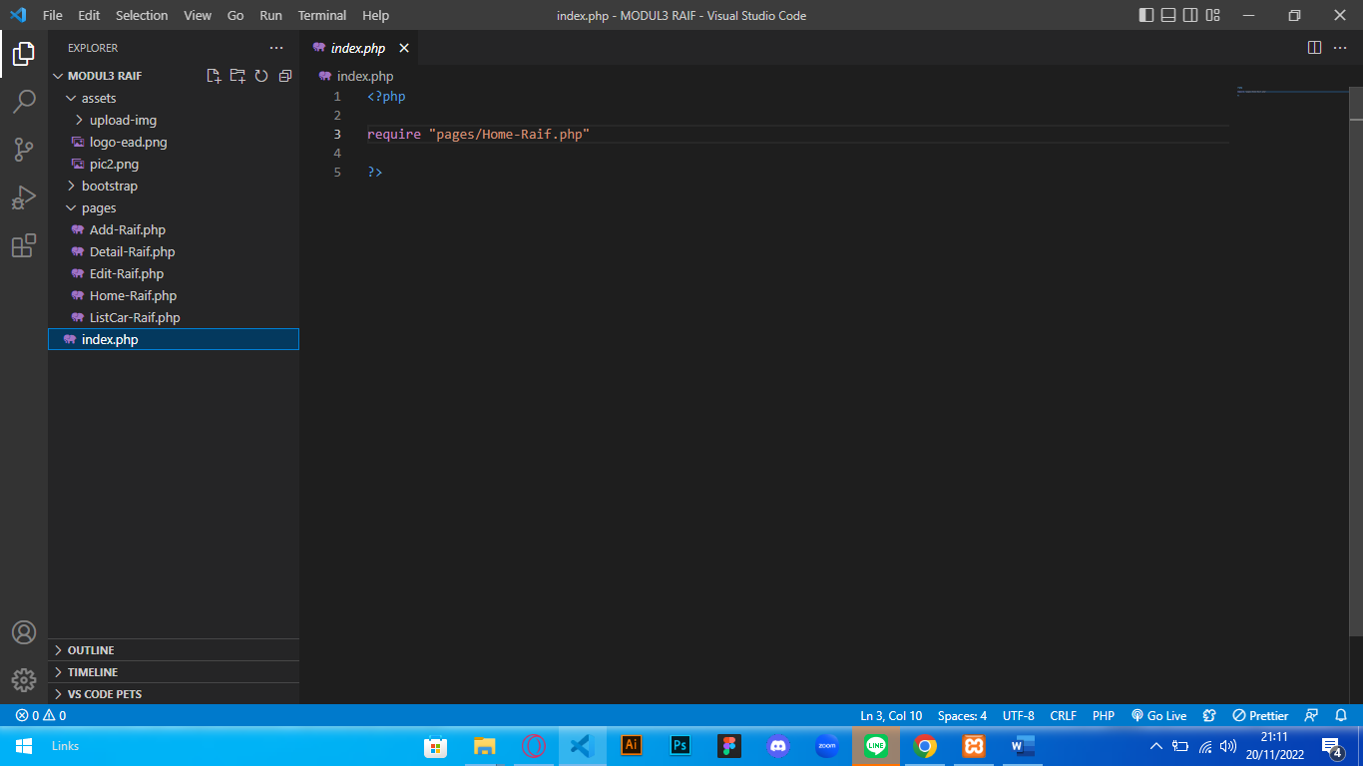

Home-Raif.php

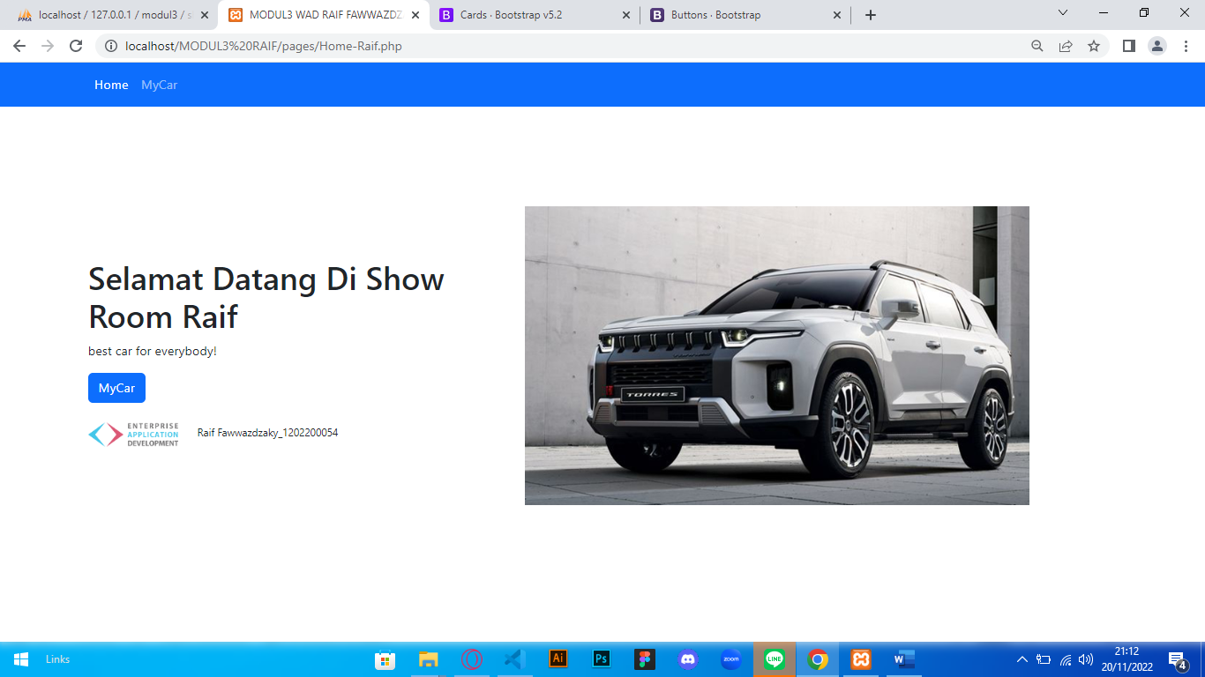

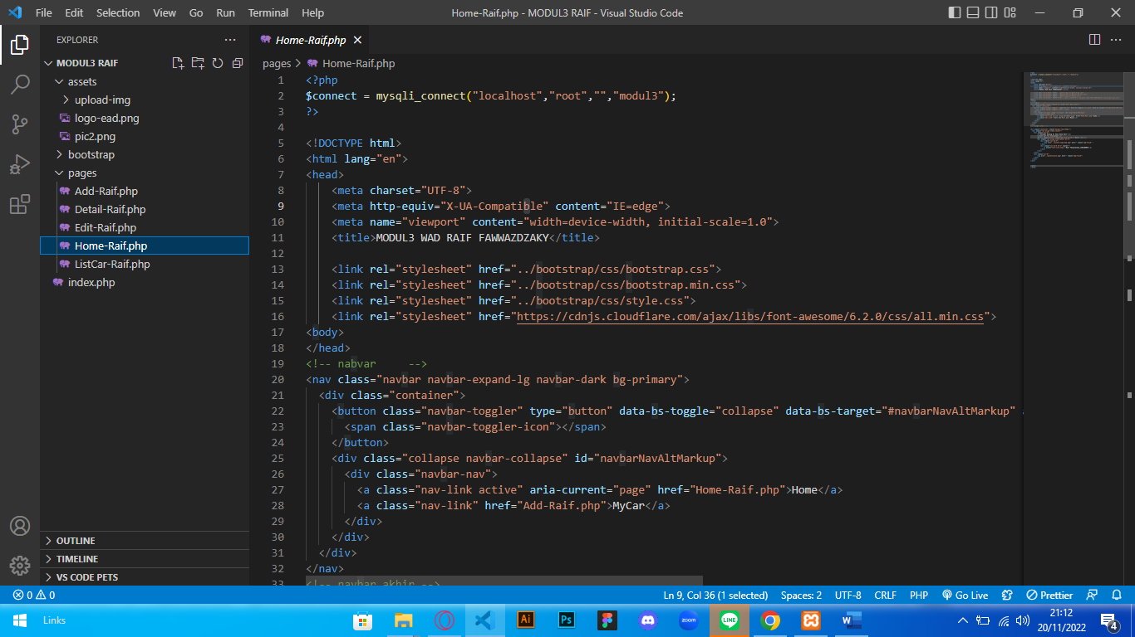

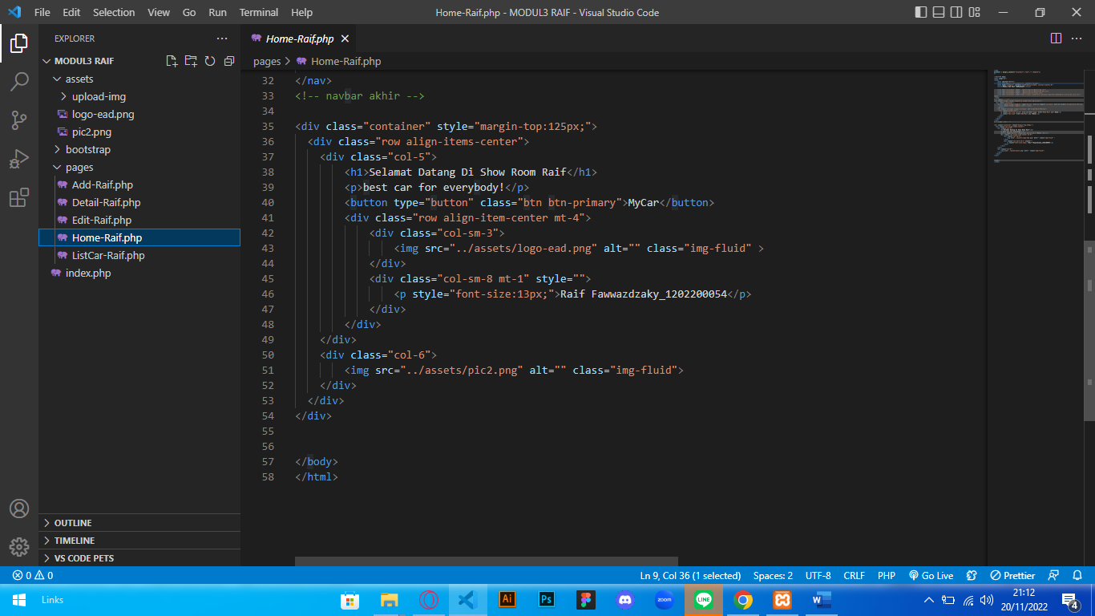

Add-Raif.php

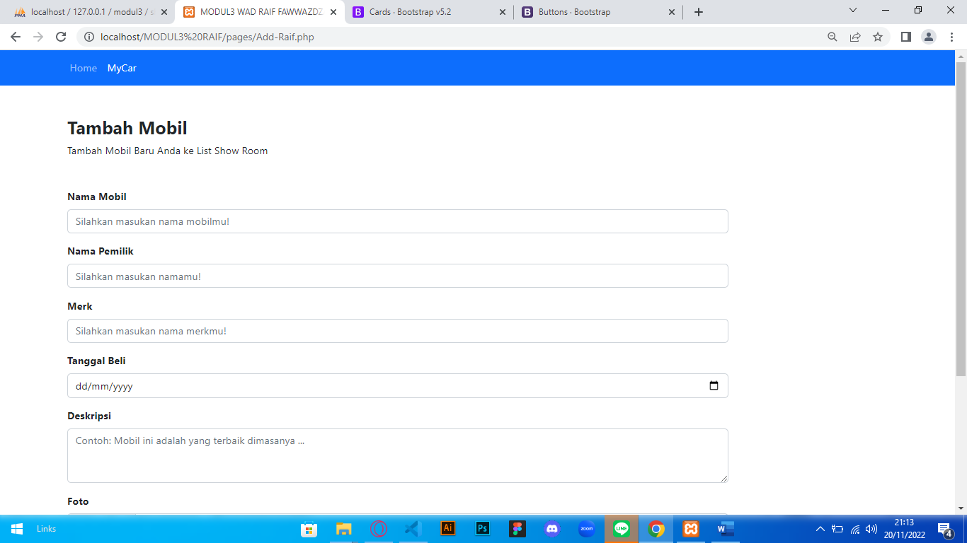

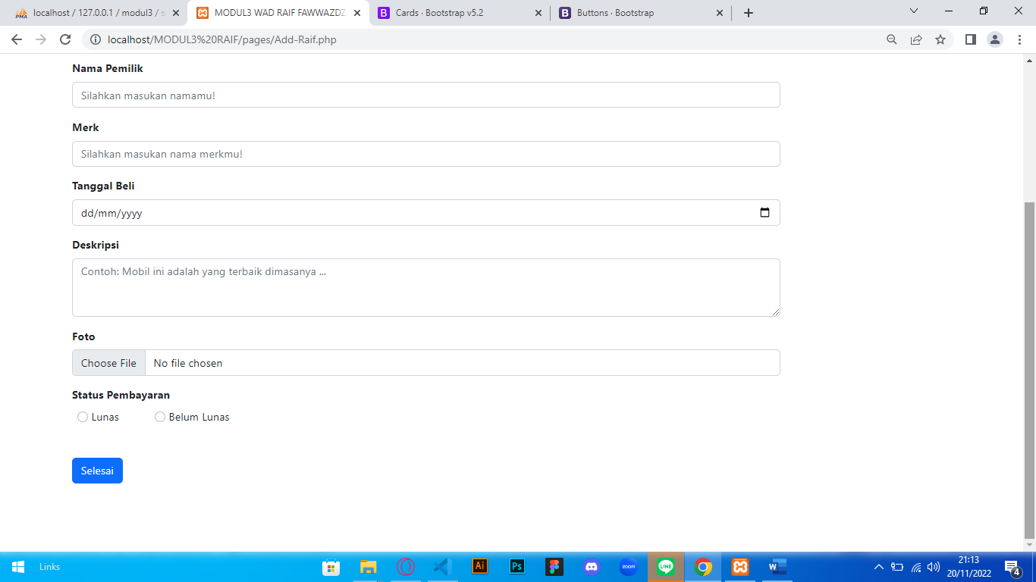

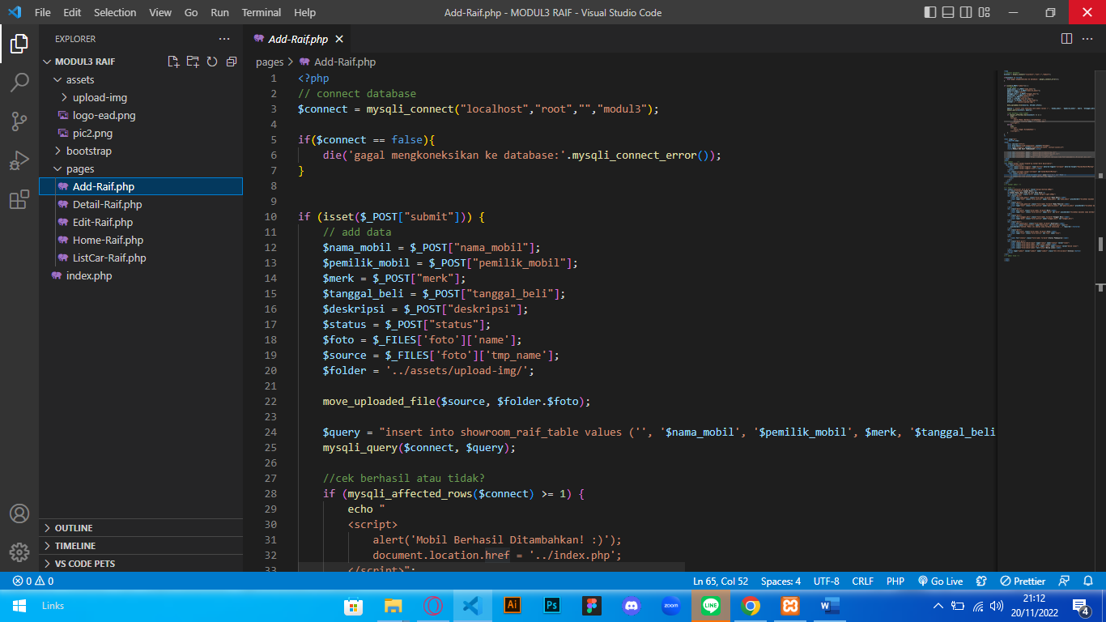

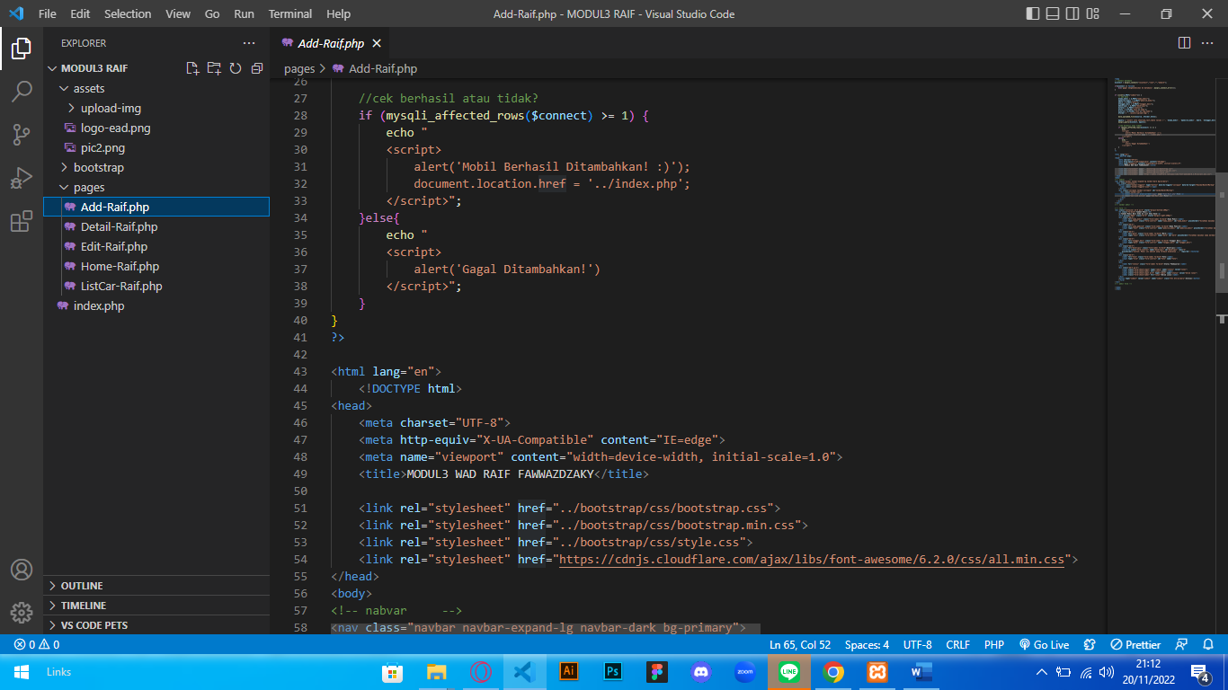

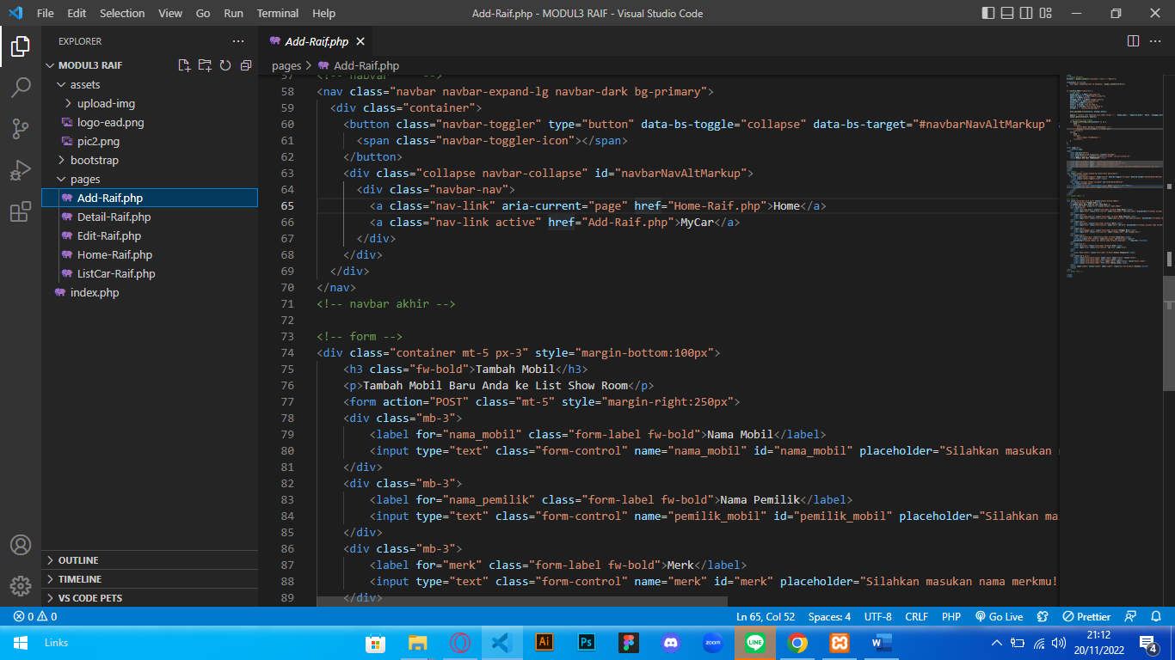

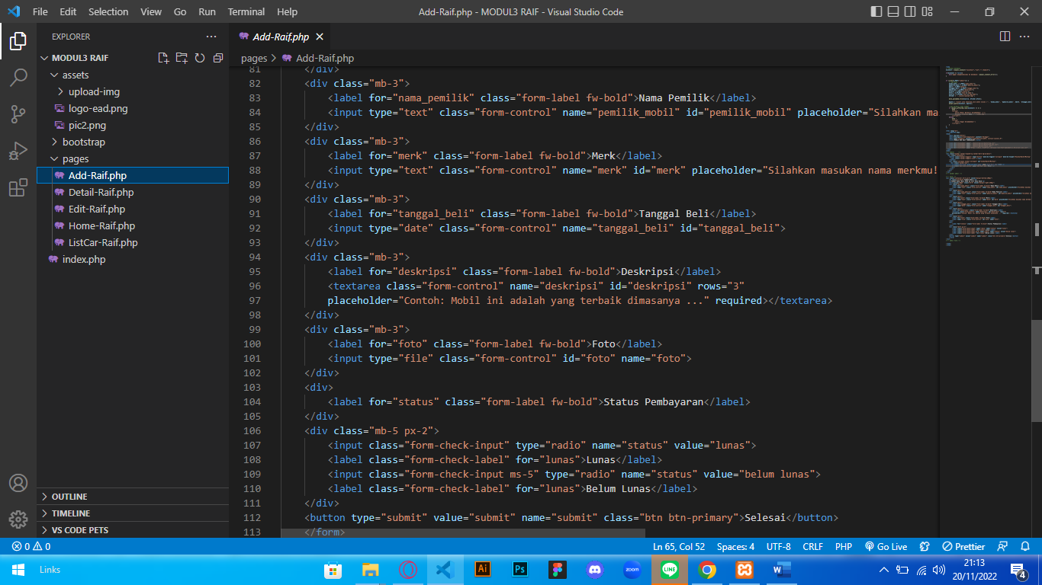

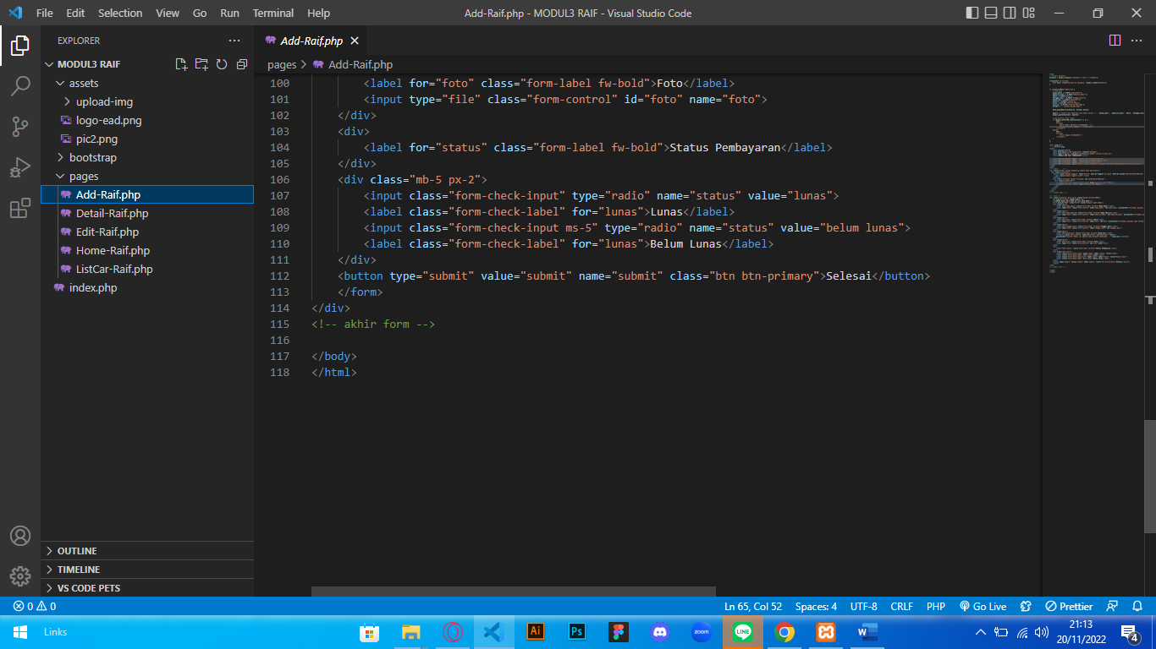

Detail-Raif.php

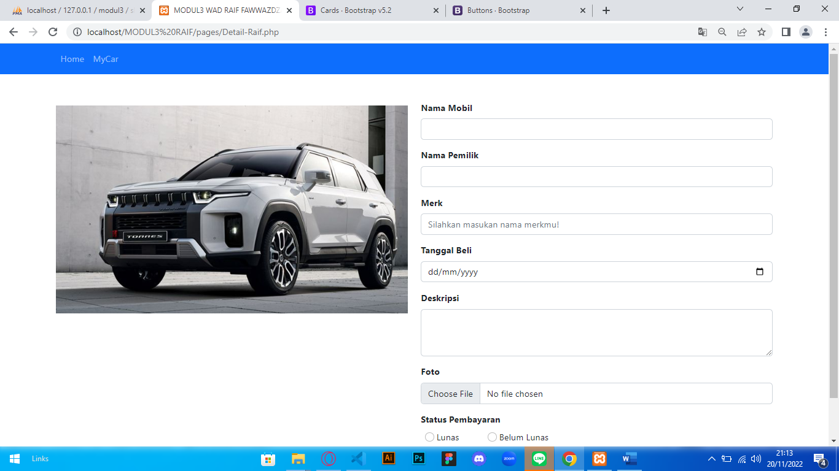

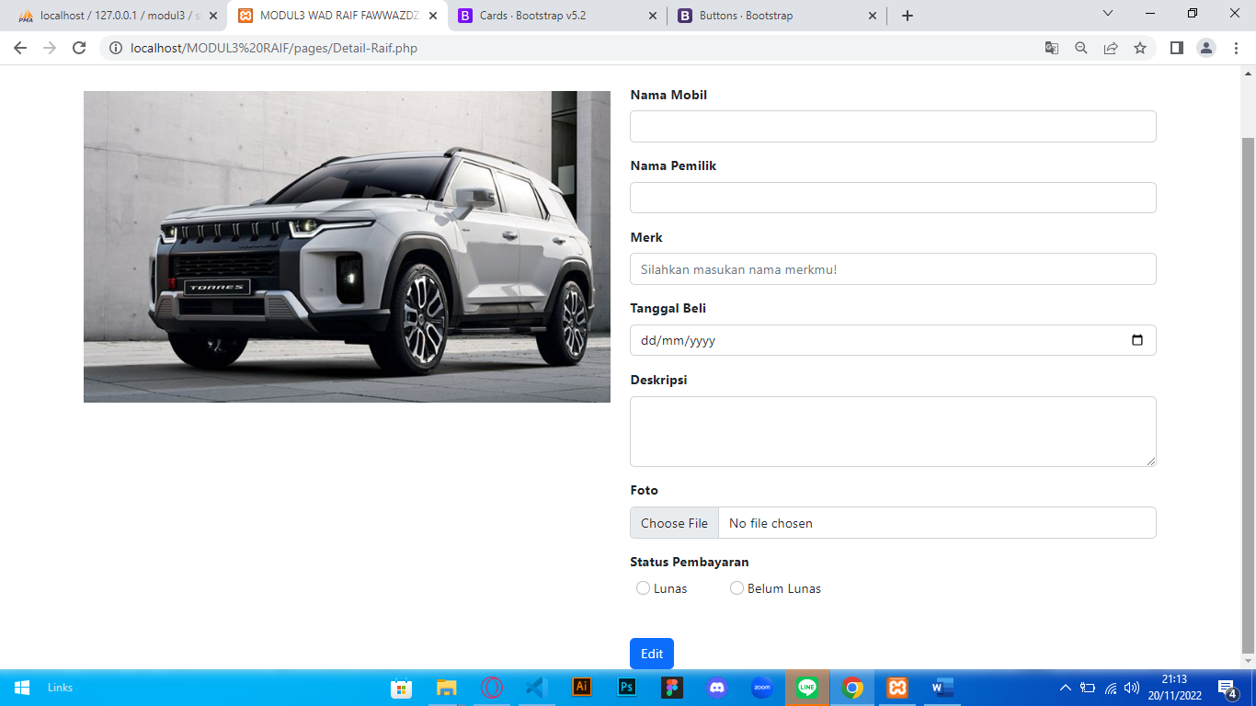

<!DOCTYPE html>

<html lang="en">

<head>

    <meta charset="UTF-8">

    <meta http-equiv="X-UA-Compatible" content="IE=edge">

    <meta name="viewport" content="width=device-width, initial-scale=1.0">

    <title>MODUL3 WAD RAIF FAWWAZDZAKY</title>

    <link rel="stylesheet" href="../bootstrap/css/bootstrap.css">

    <link rel="stylesheet" href="../bootstrap/css/bootstrap.min.css">

    <link rel="stylesheet" href="../bootstrap/css/style.css">

    <link rel="stylesheet" href="https://cdnjs.cloudflare.com/ajax/libs/font-awesome/6.2.0/css/all.min.css">

<body>

</head>

<!-- nabvar     -->

<nav class="navbar navbar-expand-lg navbar-dark bg-primary">

  <div class="container">

    <button class="navbar-toggler" type="button" data-bs-toggle="collapse" data-bs-target="#navbarNavAltMarkup" aria-controls="navbarNavAltMarkup" aria-expanded="false" aria-label="Toggle navigation">

      <span class="navbar-toggler-icon"></span>

    </button>

    <div class="collapse navbar-collapse" id="navbarNavAltMarkup">

      <div class="navbar-nav">

        <a class="nav-link" aria-current="page" href="Home-Raif.php">Home</a>

        <a class="nav-link" href="#">MyCar</a>

      </div>

    </div>

  </div>

</nav>

<!-- navbar akhir -->

<div class="container mt-5">

    <form>

    <div class="row">

        <!-- gambar -->

        <div class="col">

            <div class="d-flex align-items:center mt-2">

            <img src="../assets/pic2.png" class="card-img-top" alt="Innova">

            </div>

        </div>

        <!-- akhir gambar -->

        <!-- detail -->

        <div class="col">

            <form class="mt-5" style="margin-right:250px">

            <div class="mb-3">

                <label for="nama_mobil" class="form-label fw-bold">Nama Mobil</label>

                <input type="text" class="form-control" id="nama_mobil">

            </div>

            <div class="mb-3">

                <label for="nama_pemilik" class="form-label fw-bold">Nama Pemilik</label>

                <input type="text" class="form-control" id="nama_pemilik">

            </div>

            <div class="mb-3">

                <label for="merk" class="form-label fw-bold">Merk</label>

                <input type="text" class="form-control" id="merk" placeholder="Silahkan masukan nama merkmu!">

            </div>

            <div class="mb-3">

                <label for="tanggal_beli" class="form-label fw-bold">Tanggal Beli</label>

                <input type="date" class="form-control" id="tanggal_beli">

            </div>

            <div class="mb-3">

                <label for="deskripsi" class="form-label fw-bold">Deskripsi</label>

                <textarea class="form-control" name="deskripsi" id="deskripsi" rows="3"></textarea>

            </div>

            <div class="mb-3">

                <label for="foto" class="form-label fw-bold">Foto</label>

                <input type="file" class="form-control" id="foto">

            </div>

            <div>

                <label for="status_pembayaran" class="form-label fw-bold">Status Pembayaran</label>

            </div>

            <div class="mb-5 px-2">

                <input class="form-check-input" type="radio" name="flexRadioDefault" id="lunas">

                <label class="form-check-label" for="lunas">Lunas</label>

                <input class="form-check-input ms-5" type="radio" name="flexRadioDefault" id="lunas">

                <label class="form-check-label" for="lunas">Belum Lunas</label>

            </div>

            <button type="submit" class="btn btn-primary">Edit</button>

            </form>

            <!-- akhir detail -->

        </div>

    </div>

    </div>

    <!-- akhir form -->

<!-- akhir detail -->

<!-- akhir content -->

ListCar-Raif.php

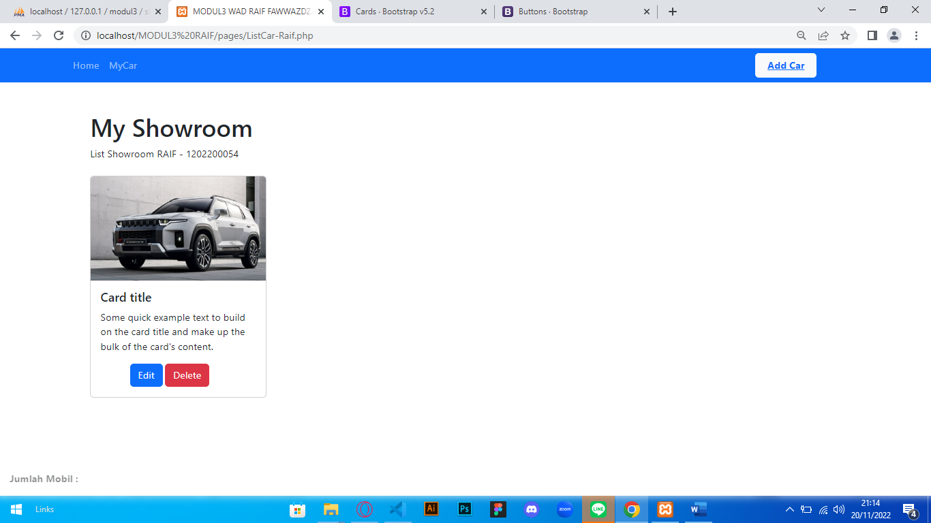

<!DOCTYPE html>

<html lang="en">

<head>

    <meta charset="UTF-8">

    <meta http-equiv="X-UA-Compatible" content="IE=edge">

    <meta name="viewport" content="width=device-width, initial-scale=1.0">

    <title>MODUL3 WAD RAIF FAWWAZDZAKY</title>

    <link rel="stylesheet" href="../bootstrap/css/bootstrap.css">

    <link rel="stylesheet" href="../bootstrap/css/bootstrap.min.css">

    <link rel="stylesheet" href="../bootstrap/css/style.css">

    <link rel="stylesheet" href="https://cdnjs.cloudflare.com/ajax/libs/font-awesome/6.2.0/css/all.min.css">

<body>

</head>

<!-- nabvar     -->

<nav class="navbar navbar-expand-lg navbar-dark bg-primary">

  <div class="container">

    <button class="navbar-toggler" type="button" data-bs-toggle="collapse" data-bs-target="#navbarNavAltMarkup" aria-controls="navbarNavAltMarkup" aria-expanded="false" aria-label="Toggle navigation">

      <span class="navbar-toggler-icon"></span>

    </button>

    <div class="collapse navbar-collapse" id="navbarNavAltMarkup">

      <div class="navbar-nav">

        <a class="nav-link" aria-current="page" href="Home-Raif.php">Home</a>

        <a class="nav-link" href="Add-Raif.php">MyCar</a>

        <button type="button" style="width: 100px;position:relative;left:1000px;" class="btn btn-light fw-bold">

        <a href="Add-Raif.php">Add Car</a></button>

      </div>

    </div>

  </div>

</nav>

<!-- navbar akhir -->

<div class="container mt-5 px-5">

    <h1>My Showroom</h1>

    <p>List Showroom RAIF - 1202200054</p>

    <div class="row">

        <div class="col">

        <div class="card mt-2" style="width: 18rem;">

            <img src="../assets/pic2.png" class="card-img-top" alt="...">

            <div class="card-body">

                <h5 class="card-title">Card title</h5>

                <p class="card-text">Some quick example text to build on the card title and make up the bulk of the card's content.</p>

                <div class="container px-5">

                    <a href="#" class="btn btn-primary">Edit</a>

                    <a href="#" class="btn btn-danger">Delete</a>

                </div>

            </div>

            </div>

        </div>

    </div>

    <div class="container mt-5">

        <p class="fw-bold opacity-50 fixed-bottom px-3">Jumlah Mobil :</p>

    </div>

</div>

</body>

</html>

Edit-Raif.php

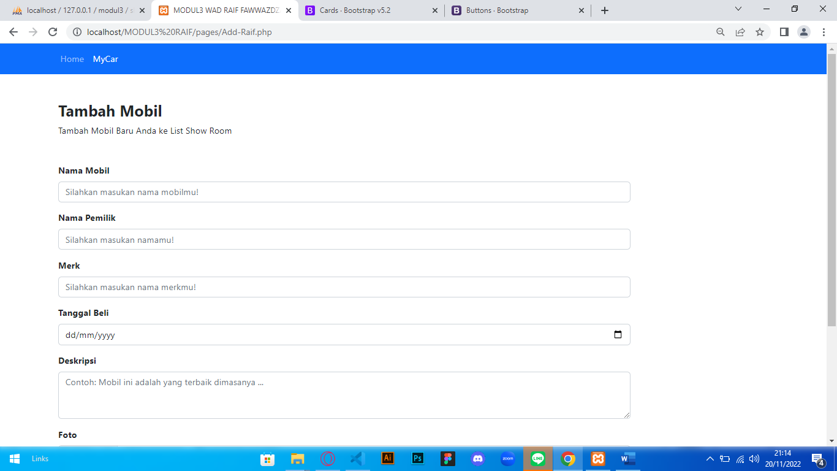

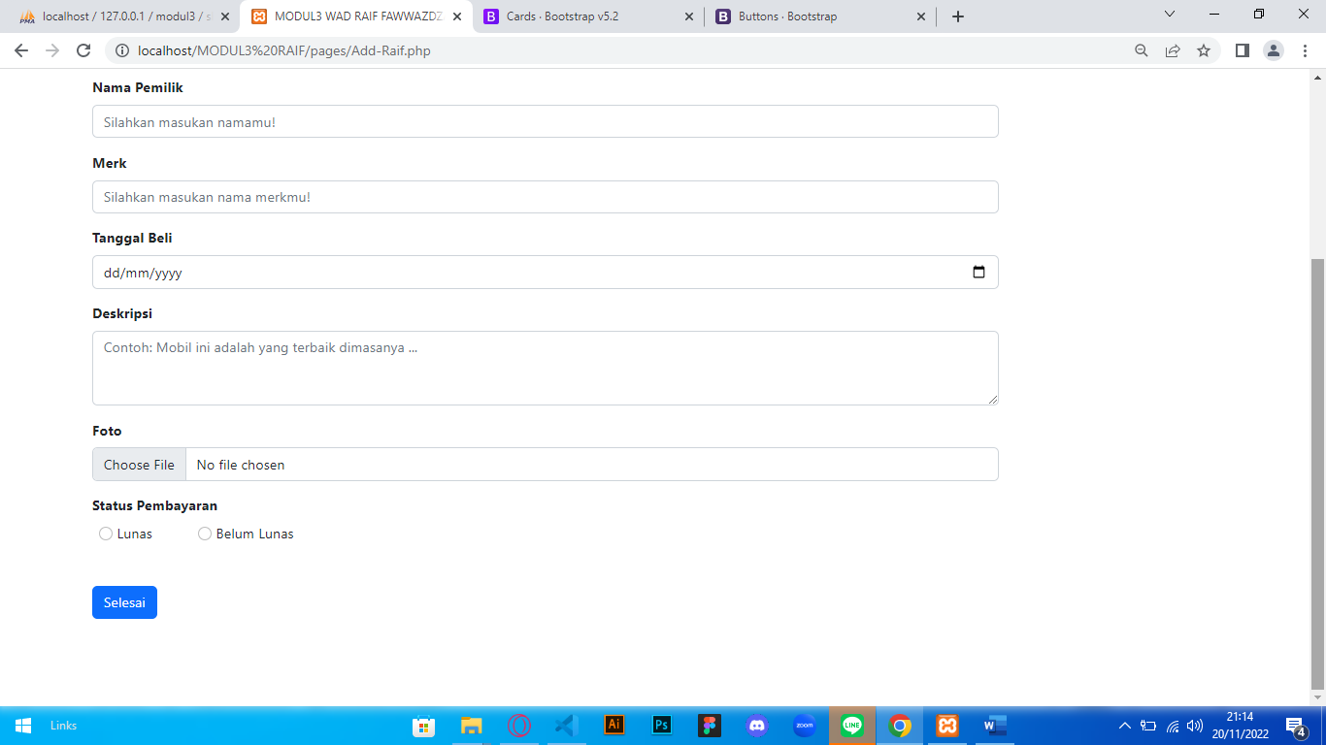

<?php

// connect database

$connect = mysqli_connect("localhost","root","","modul3");

if($connect == false){

    die('gagal mengkoneksikan ke database:'.mysqli_connect_error());

}

if (isset($_POST["submit"])) {

    // add data

    $nama_mobil = $_POST["nama_mobil"];

    $pemilik_mobil = $_POST["pemilik_mobil"];

    $merk = $_POST["merk"];

    $tanggal_beli = $_POST["tanggal_beli"];

    $deskripsi = $_POST["deskripsi"];

    $status = $_POST["status"];

    $foto = $_FILES['foto']['name'];

    $source = $_FILES['foto']['tmp_name'];

    $folder = '../assets/upload-img/';

    move_uploaded_file($source, $folder.$foto);

    $query = "insert into showroom_raif_table values ('', '$nama_mobil', '$pemilik_mobil', $merk, '$tanggal_beli', '$deskripsi', '$foto', '$status')";

    mysqli_query($connect, $query);

    //cek berhasil atau tidak?

    if (mysqli_affected_rows($connect) >= 1) {

        echo "

        <script>

            alert('Mobil Berhasil Ditambahkan! :)');

            document.location.href = '../index.php';

        </script>";

    }else{

        echo "

        <script>

            alert('Gagal Ditambahkan!')

        </script>";

    }

}

?>

<html lang="en">

    <!DOCTYPE html>

<head>

    <meta charset="UTF-8">

    <meta http-equiv="X-UA-Compatible" content="IE=edge">

    <meta name="viewport" content="width=device-width, initial-scale=1.0">

    <title>MODUL3 WAD RAIF FAWWAZDZAKY</title>

    <link rel="stylesheet" href="../bootstrap/css/bootstrap.css">

    <link rel="stylesheet" href="../bootstrap/css/bootstrap.min.css">

    <link rel="stylesheet" href="../bootstrap/css/style.css">

    <link rel="stylesheet" href="https://cdnjs.cloudflare.com/ajax/libs/font-awesome/6.2.0/css/all.min.css">

</head>

<body>

<!-- nabvar     -->

<nav class="navbar navbar-expand-lg navbar-dark bg-primary">

  <div class="container">

    <button class="navbar-toggler" type="button" data-bs-toggle="collapse" data-bs-target="#navbarNavAltMarkup" aria-controls="navbarNavAltMarkup" aria-expanded="false" aria-label="Toggle navigation">

      <span class="navbar-toggler-icon"></span>

    </button>

    <div class="collapse navbar-collapse" id="navbarNavAltMarkup">

      <div class="navbar-nav">

        <a class="nav-link" aria-current="page" href="Home-Raif.php">Home</a>

        <a class="nav-link active" href="Add-Raif.php">MyCar</a>

      </div>

    </div>

  </div>

</nav>

<!-- navbar akhir -->

<!-- form -->

<div class="container mt-5 px-3" style="margin-bottom:100px">

    <h3 class="fw-bold">Tambah Mobil</h3>

    <p>Tambah Mobil Baru Anda ke List Show Room</p>

    <form action="POST" class="mt-5" style="margin-right:250px">

    <div class="mb-3">

        <label for="nama_mobil" class="form-label fw-bold">Nama Mobil</label>

        <input type="text" class="form-control" name="nama_mobil" id="nama_mobil" placeholder="Silahkan masukan nama mobilmu!">

    </div>

    <div class="mb-3">

        <label for="nama_pemilik" class="form-label fw-bold">Nama Pemilik</label>

        <input type="text" class="form-control" name="pemilik_mobil" id="pemilik_mobil" placeholder="Silahkan masukan namamu!">

    </div>

    <div class="mb-3">

        <label for="merk" class="form-label fw-bold">Merk</label>

        <input type="text" class="form-control" name="merk" id="merk" placeholder="Silahkan masukan nama merkmu!">

    </div>

    <div class="mb-3">

        <label for="tanggal_beli" class="form-label fw-bold">Tanggal Beli</label>

        <input type="date" class="form-control" name="tanggal_beli" id="tanggal_beli">

    </div>

    <div class="mb-3">

        <label for="deskripsi" class="form-label fw-bold">Deskripsi</label>

        <textarea class="form-control" name="deskripsi" id="deskripsi" rows="3"

        placeholder="Contoh: Mobil ini adalah yang terbaik dimasanya ..." required></textarea>

    </div>

    <div class="mb-3">

        <label for="foto" class="form-label fw-bold">Foto</label>

        <input type="file" class="form-control" id="foto" name="foto">

    </div>

    <div>

        <label for="status" class="form-label fw-bold">Status Pembayaran</label>

    </div>

    <div class="mb-5 px-2">

        <input class="form-check-input" type="radio" name="status" value="lunas">

        <label class="form-check-label" for="lunas">Lunas</label>

        <input class="form-check-input ms-5" type="radio" name="status" value="belum lunas">

        <label class="form-check-label" for="lunas">Belum Lunas</label>

    </div>

    <button type="submit" value="submit" name="submit" class="btn btn-primary">Selesai</button>

    </form>

</div>

<!-- akhir form -->

</body>

</html>